COMPUTER NETWORKS
COEN233

Development of a new service using
Wi-Fi Direct

HE SHOUCHUN
MEENAKSHI HARIKUMAR
NAGA TULASI SOUJANYA VADREVU

INDEX
6. Implementation--------------------------------------------------------------------------------------------3
- code ---------------------------------------------------------------------------------------------------
- design document and flowchart------------------------------------------------------------------4
7. Data analysis and discussion----------------------------------------------------------------------------5
- output generation-----------------------------------------------------------------------------------6
- output analysis---------------------------------------------------------------------------------------6
- compare output against hypothesis-------------------------------------------------------------6
- abnormal case explanation------------------------------------------------------------------------7
- statistic regression----------------------------------------------------------------------------------8
- discussion---------------------------------------------------------------------------------------------9
TEST CASES-------------------------------------------------------------------------------------------10
PROBLEMS WITH Wi-Fi Direct------------------------------------------------------------------12
8. Conclusions and recommendations-------------------------------------------------------------14
- summary and conclusions-----------------------------------------------------------------------14
- recommendations for future studies-----------------------------------------------------------15
9. bibliography------------------------------------------------------------------------------------------15
10. appendices-------------------------------------------------------------------------------------------15
- program flowchart--------------------------------------------------------------------------------13
- program source code with documentation--------------------------------------------------15
- input/output listing-------------------------------------------------------------------------------10

6. IMPLEMENTATION
DESIGN DOCUMENT:
Introduction:
Designing a messaging application using Wi-Fi direct on Android framework.
We have built a messaging application between the mobile devices using Wi-Fi Direct
Our problem can be simply described as that when 2 mobile devices encounter with each other, one need to detect whether there is a mobile in the vicinity. In the real case, it could be multiple devices sharing information at the same time.
First, before we search the peers, we need do some initialization work, such as set up the data structure.
After we find the peers, we will connect peers via Wi-Fi direct. The Wi-Fi direct has many limitations, like crash problems, only in android 4.0 device, and all the devices need open wifi-direct all the time to wait for connection. Since it is convenient, we will use it to simplify the work, and we will focus on developing the protocols and algorithm.
After connecting with peers, we will establish socket communication. Then we need use some protocols to check the information needed and availability will be used to detect whether the friend is a member of a Group. All these work will be done in the query process.
The last part is data transmission. After all the work set, we can transmit the data based on the requirement. Then the file status will be updated in the file list.
Tools Used:
- Android SDK
- Eclipse
- SQL lite
Versions Used
- Android- 4.2 Jelly bean
- IEEE 802.11 a/g/n Wi-Fi CERTIFIED gear.
- SAMSUNG Galaxy Note II, and SAMSUNG Galaxy Nexus phones
- Eclipse 4.2

Proposed Scope of the project:
The Application has to be built over the application framework. To develop an Android Application Package (APK) for instant messaging using the Wi-Fi direct.
The application features include:

- Simple text messaging
- Chat Service
- Multimedia content sharing i.e. image, audio, video and application
For example, image/jpeg, GIF, audio/mp3, video/mp4, and application/ msword

Application Design Overview
Every application runs in its own Linux process. Android starts the process when any of the application's components need to be executed, then shuts down the process when it's no longer needed or when the system must recover memory for other applications.
Current Process
A socket connection is established between the two users to exchange messages and multimedia. The information about the friends is stored in the database. The designed features for the messaging application are the friend finder, chat and group chat.
Proposed Process for future
Push notifications: Let your application notify a user of new messages or events even when the user is not actively using your application. On Android devices, when a device receives a push notification, your application's icon and a message appear in the status bar. When the user taps the notification, they are sent to your application. Notifications can be broadcast to all users, such as for a marketing campaign, or sent to just a subset of users, to give personalized information.
Multiplayer game: It’s far more realistic and competitive to play multiplayer games against real people than against computer algorithms.

7. DATA ANALYSIS and DISCUSSION
The basic steps for a Wi-Fi direct application are:
- Initial Setup
- Discovering Peers
- Connecting to Peers
- Transferring Data
ESTABLISHING THE CONNECTION:
The Client Server processes are similar to each other. The client will send out the request message upon connection set up and then waiting for messages from server. Server and client gets the requests and they open the message activity screen.
Client
Server

Send request
Receive request

Receive request

Send request

The client sends a request to the server with its IP address and the server gives back a reply with its available port connection and the connection is established.
The Friend Finder
Friend Finder is an activity integrated with location that is the range of Wi-Fi direct. Will help you and your friends find each other no matter where you are. You can choose which friends can find you then fire off your location with just the click of a button; instantly your friends know exactly where to meet up with you AND they have a map with driving, walking, or public transportation directions.
How will service discovery work?
Like all Wi-Fi technologies, Wi-Fi Direct creates IP-based networks between the devices, allowing existing service discovery methods to work just as they do over a wireless LAN today-including Bonjour and UPnP.

Wi-Fi Direct defines a new pre-association discovery method, giving Wi-Fi Direct devices the ability to discover devices and limited information about device services prior to association (and before having an IP address). Pre-association discovery improves the user experience - users will know whether a desired service (e.g. printing) will be available on the Wi-Fi Direct network before connecting.
Output Generation:
The simulation is done on the Android SDK and simulated it on Samsung Galaxy note II.
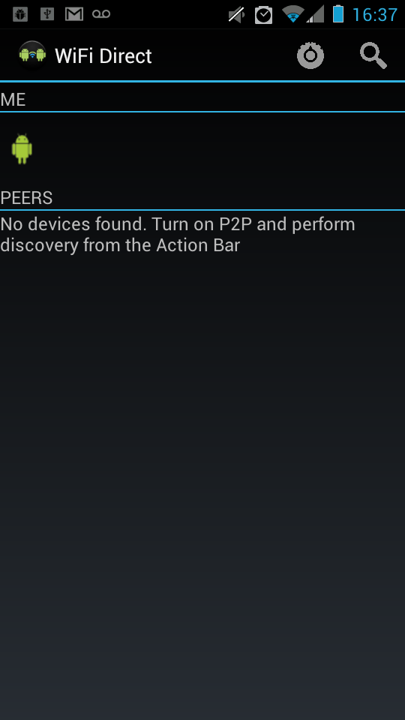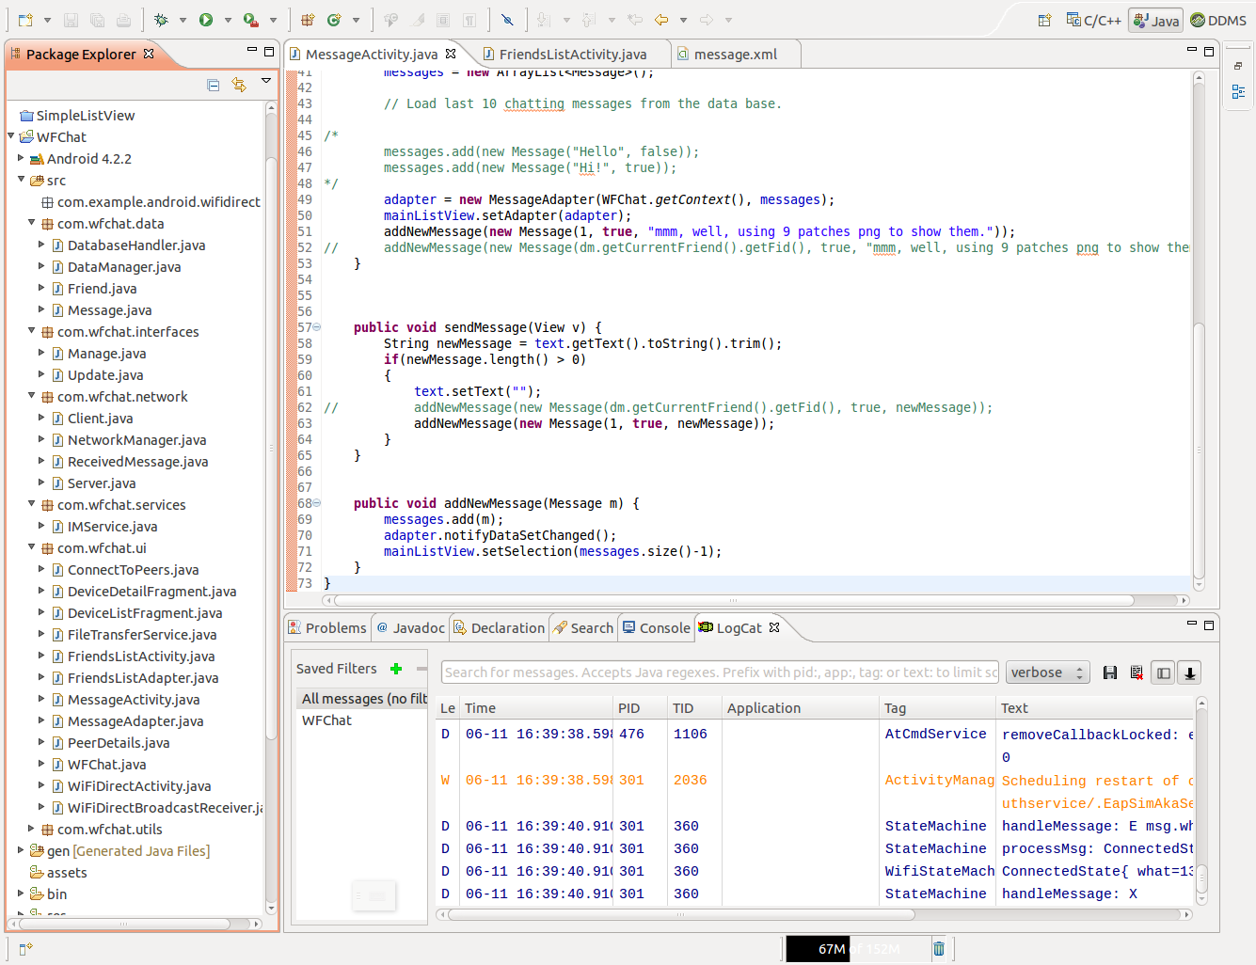
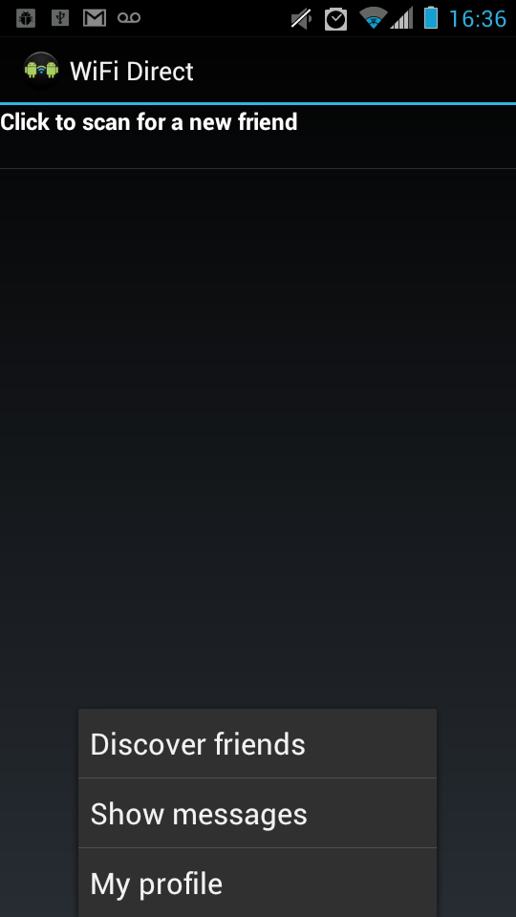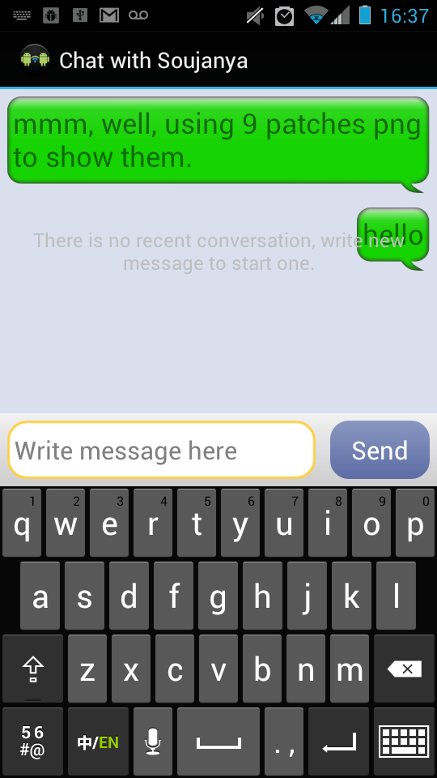
IMPLEMENTATION:

Application
User Interface
Layer
DATA MANAGER
Transport
SOCKET
Layer

Wi Fi direct

User interface is used to connect to the bottom layers. Connection is established between the two ends. The Data Manager maintains the information about the users. Once the connection is established the two users exchange the profile data and then we determine
Friend: contains the profile data: name, gender, age are entered in a list
When we establish the connection we send the following details for authentication Friend finder is the same as customer finder .We can use all the details to prove their authenticity
Compare Output against Hypothesis:
The instant messaging application with features of chat service, save friends details worked well after establishing the socket connection. Binding this code with Wi-Fi direct layer did not return the expected results due to the hardware issues in the devices.
Due to the limitations of Wi-Fi Direct layer, extending the design for other features like exchanging the multimedia content, multiplayer games and push notifications is not possible as of now.

TEST CASES:
CASE 1: make connection
CASE 2: Save friends
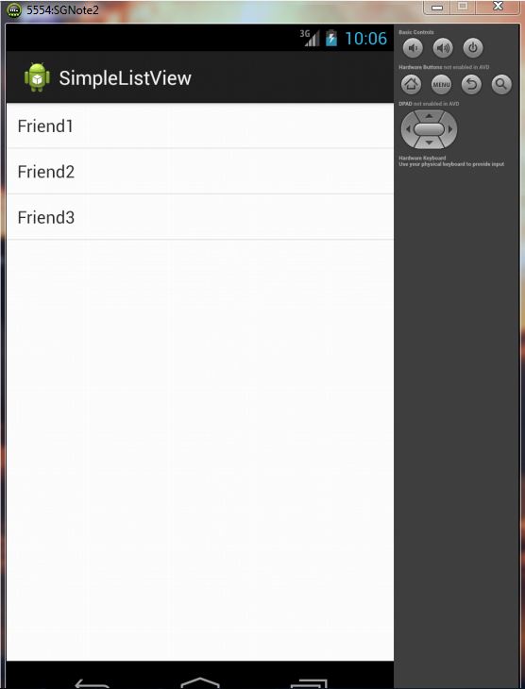
This is copied to the database
CASE 3: exchange friends profile
Friend details: name, age, MAC address, IP are exchanged.MAC address is sent for the verification
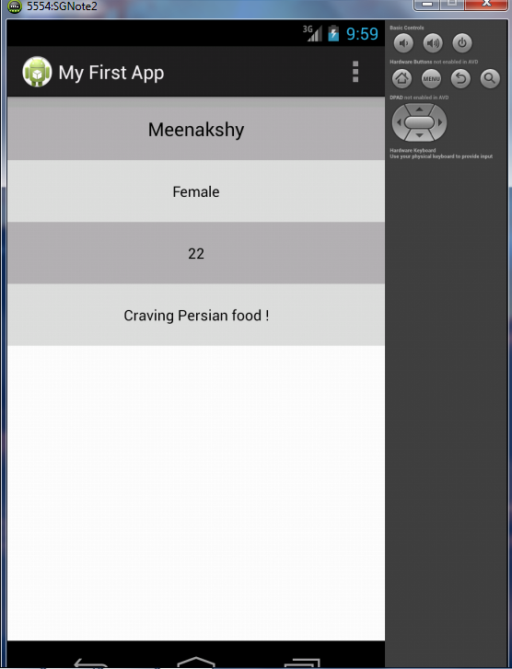
CASE 4: send message and receive message
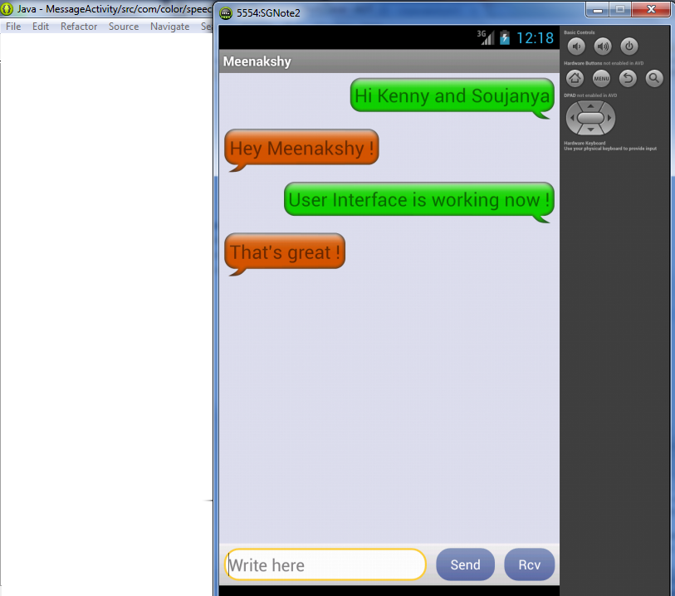

Problems with Wi-Fi Direct:
The problems we have observed while developing the application are that
- Wi-Fi Direct is still a emerging technology.
- How many devices can connect?
A Wi-Fi Direct-certified network can be one-to-one, or one to-many. The number of devices in a Wi-Fi Direct-certified group network is expected to be smaller than the number supported by traditional standalone access points intended for consumer use. Connection to multiple other devices is an optional feature that will not be supported in all Wi-Fi Direct-certified devices; some devices will only make 1:1 connections.
- Connection to multiple other devices is an optional feature that will not be supported in all Wi-Fi Direct-certified devices; some devices will only make 1:1 connections.
- Wi-Fi Direct-certified devices will be identifiable as Wi-Fi Direct-certified devices to infrastructure access points. APs can prevent devices currently using Wi-Fi Direct from connecting to the AP, or disconnect them if already connected, while Wi-Fi Direct is in use and/or configure their parameters including channel.
- Several Wi-Fi Alliance members that make devices of limited processing capabilities contributed to the specification development process to ensure that it is applicable to such devices.
- Bluetooth and Wi-Fi Interference Cases
- A Wi-Fi receiver senses a Bluetooth signal at the same time a Wi-Fi signal is being sent to it. The effect is most pronounced when the Bluetooth signal is within the 22-MHz-wide pass band of the Wi-Fi receiver.
- A Bluetooth receiver senses a Wi-Fi signal at the same time a Bluetooth signal is being sent to it; the effect is most pronounced when the Wi-Fi signal is within the pass band of the Bluetooth receiver

These problems have caused a major hindrance in the development of the application.

FLOW OF THE DESIGN
Friends list view

Search around

Select device and connect

connect

Yes No

exists
Exchange profile
yes
Open message activity

no
Add data to data manager

Open message activity

CONCLUSION:
The introduction of the Wi-Fi Direct protocol [1] represents an opportunity to support P2P in a way that can effectively relieve the overload on some mobile networks. Both Internet Service Providers (ISPs) and consumers could beneﬁt from this. Wi-Fi Direct will allow a mobile to connect directly with another mobile in its range that is also running the protocol, with no hubs or routers are involved. Data rates are expected to be over 250 Mbps with a coverage range of about 100 meters. In this paper, we have presented the messaging application using Wi-Fi direct to exchange data. The limitations of Wi-Fi direct make it less user friendly. The numbers of devices with Wi-Fi direct devices are very few.
The major problem a user confronts when using the Wi-Fi direct is that the device are not compatible with each other. The device crashes or gets stuck if we try to exchange multimedia. The solution to overcome this problem is to develop the link layer and see that the connection is still on when the exchange is going on. This Application would work in a better way if there is device compatibility and Wi-Fi direct is extended to all the smart devices.
Finally, if Wi-Fi Direct becomes a widespread technology as expected, it faces the challenge of improving coexistence.
FUTURE RECOMMENDATIONS:
In addition to better marketing, there are several other factors that could give Wi-Fi Direct a much-needed boost in the near future.
First, the number of connected devices as a whole is on the rise, as manufacturers seek to add IP connectivity to everything from cameras to tablets and TVs. The Wi-Fi Alliance also threw its lot in with the Digital Living Network Alliance (DLNA) last November, ensuring that DLNA-certified devices now also support Wi-Fi Direct.
Second, more Wi-Fi Direct devices are still on the way. In-Stat predicts that every connected device with Wi-Fi will ship with Wi-Fi Direct by 2014. Given that Wi-Fi Direct devices are also backwards-compatible with other Wi-Fi products that means a huge number of consumer electronics will be capable of connecting over local wireless networks without the Internet. Only one device in each wireless pairing has to be Wi-Fi Direct-enabled.

BIBLIOGRAPHY
http://www.android-app-market.com/android-architecture.html
http://www.wi-fi.org/files/faq_20101021_Wi-Fi_Direct_FAQ.pdf
http://anrg.usc.edu/ee579_2012/Group09/#wifidirect

